**KINZE Blue Vantage: Loading Planting Prescriptions**

1. Insert USB
2. Select MANAGE  
   
3. Select PRESCRIPTION AND BOUNDARY FILES

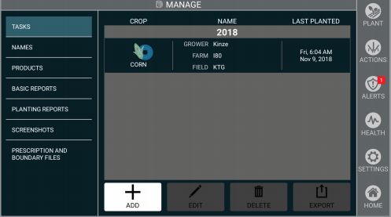

1. Select IMPORT  
   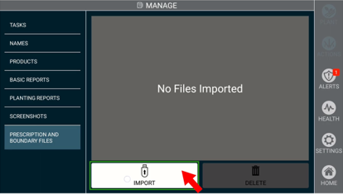
2. You can select just the field(s) you want to load or Select All  
   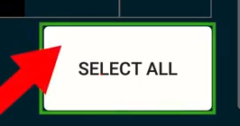
3. Select the checkbox  
   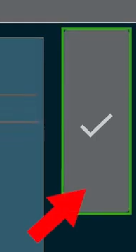
4. The Prescription files are now Imported into the display
5. Go back to the Home screen
6. Select PLANT  
   
7. Select ADD  
   
8. Select the PRESCRIPTION box on the lower left-hand corner of screen  
   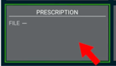
9. Select the Prescription you want from the list, make sure it is highlighted once selected
10. Select the checkbox  
    
11. You will now see the prescription in the PRESCRIPTION box in the left-hand corner of the screen  
    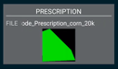
12. The POPULATION box in the center of the screen will show you are using an Rx  
    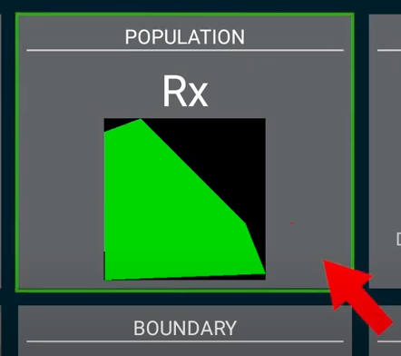
13. Select PLANT- you are ready to go!  
    